A quiz as a way to enhance communication and to compare findings more effective
Why a quiz in a project?
- In the On-Stage project the students have to learn very well about the topic of the other country. They write a script of a TV show where they present a topic related to the other country and they perform and record that TV show. E.g. Indian students perform a TV show on the Dutch food. For the Comparison stage, the Indian students need to find out whether the Dutch students have studied the topic Indian food well.
- Connection issues and difference of accents may cause wastage of time. Organizing small quizzes for each group would avoid this wastage of time and make the comparison most effective. The students can read the quiz questions and the options and answer either verbally or in the zoom chat.

Preparation
- Teachers explain the importance of the comparison to students. If the group scores 5/5 in your quiz, it means they have studied your country’s topic very well. If they score a 3/5, it means they have partly studied, and, if they score 1/5 it would mean they haven’t done a good job at knowing the other country.
- Each group prepares a PPT of 5 questions each on their respective topics. E.g. Local foods of India, local games of India, local festivals of India, School Culture, Wildlife and Nature of India.
Rules
- Use the main Room of Zoom so that all could witness and benefit from the Q+As.
- In the main room, one teacher gives the general instructions. One teacher keeps time and another keeps the scores.
- Use the ‘Hide Non- Video Participants’ feature on Zoom. This allows the main groups ‘asking and taking’ the Quiz to be visible on screen while all other participants are not visible, yet be present.
- Set a time limit. E.g. 30 sec for each question and a pool of 25 questions to be completed in 30 min.
- Each sub-group allots a Quiz-master, a time-keeper and a score-keeper for its group. The other 2 students are also ready to take over as back-up in case someone’s network fails.
Agenda

- Welcome, introduction of agenda (timing) and explanation of rules and settings. (5 min)
- Main Room – Quiz: The Teacher timekeeper gives turns. Topic 1. E.g. Food. Two groups switch on their cameras. (6 min / group = 30 min)
Indian Group Food (alternatively Dutch) shares its PPT with 5 questions. Dutch students (alternatively Indian) answer verbally or in the chat. Student timekeeper shows an online timer. Student Scorekeeper announces the score for the team. We move on to the next
Topic 2…. and follow the same procedure.
- After the quiz, the students are put into Break out rooms for freer interaction and free discussion. (10 min)
- For the closure students are brought back to the Main Room. (5 min)
Technical requirements.
- Zoom with unlimited time feature
- Activate share screen to allow students to show the PPT
- Activate breakout room option
- Activate ‘Hide Non-Video Participants’ on video settings. This allows two groups with the same topic ‘asking and taking’ the Quiz to be visible on screen while all other participants wouldn’t be visible, yet be present.
Suggestions
- Each student renames himself/herself with first name and Group name
- If possible students put a virtual background of their group topic, e.g. Group food with a food photo as their virtual background. It is easier for the host teacher to 10 minutes identify the students and to put them into breakout rooms.
Evaluation
- The students of both the schools were comfortable with each other and they were freely asking questions and answering them with confidence.
- Each group has highlighted the scores of the Dutch group and evaluated their findings based on the input given earlier on their Weebly pages.

Agenda.  Introduction. Main Room.  Slide with instructions | 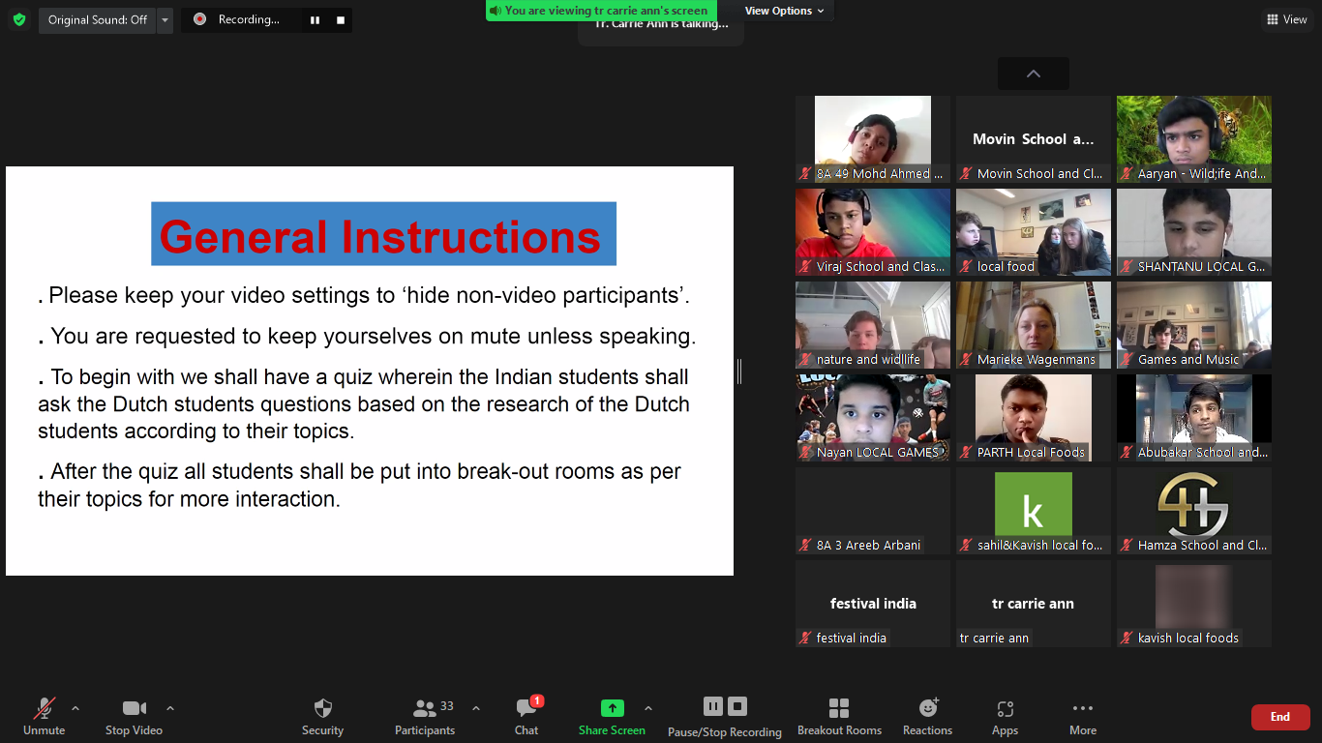
Main Room in the Zoom session. (Using the ‘Hide Non-Video Participants’ Feature)  Slide with question for Dutch students.  An online timer- It’s a student’s phone displaying the timer. | 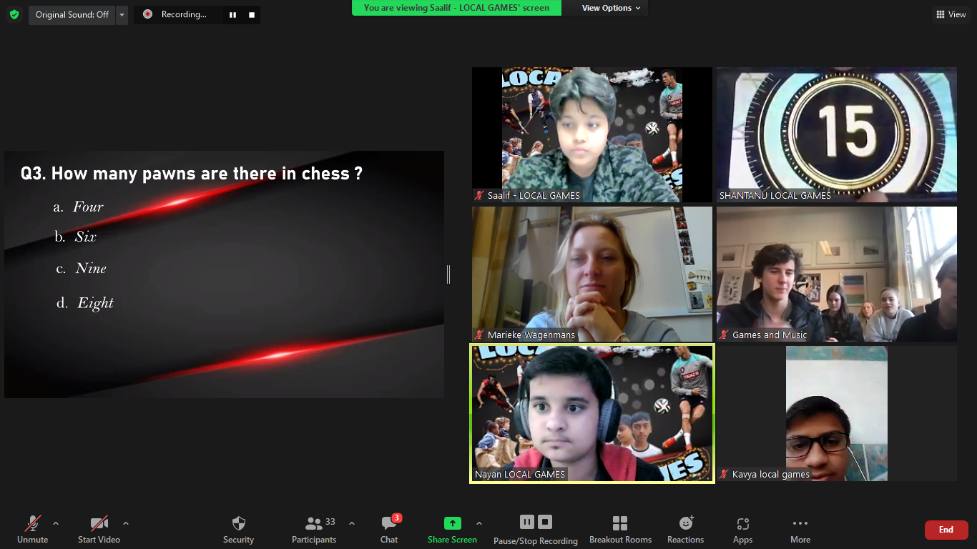
Main Room in the Zoom session. (Using the ‘Hide Non-Video Participants’ Feature)  Slide with question for Dutch students. | 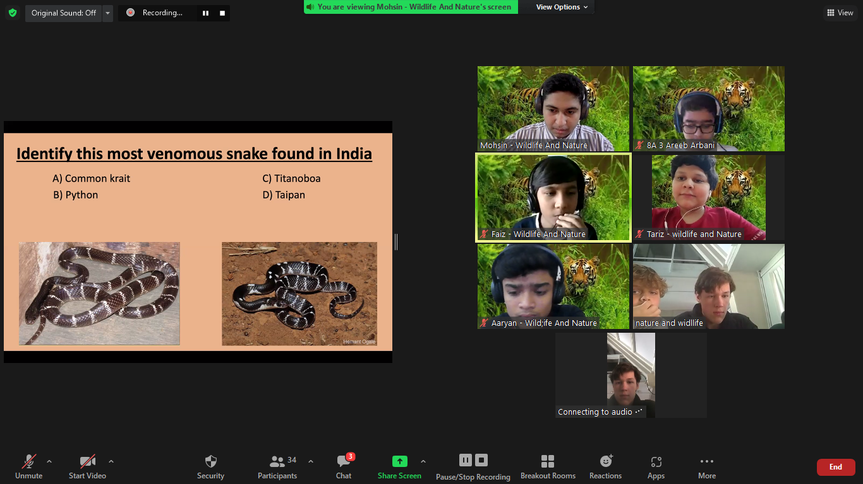
- Main Room. Closure | - 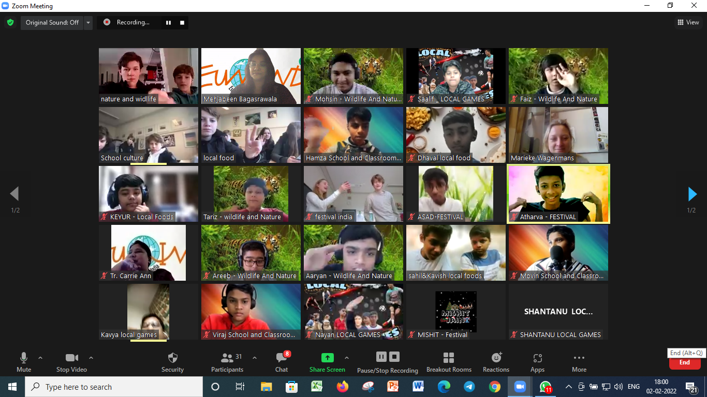
~Mehjabeen Bagasrawala (Teacher Coordinator- St. Mary’s High School S.S.C.)

